Earth Quake Prediction Model in Python IBM Project(naan mudhalvan)

TEAM MEMBERS

1. DHAKSHINAMOORTHY.M
2. HARIHARAN.V
3. DHANAVEL.M
4. DEEPAK.D

**Abstract:**

Earthquakes represent one of the most devastating and unpredictable natural disasters, making the development of reliable prediction methods a critical research endeavor. This abstract provides a comprehensive overview of recent advancements in earthquake prediction, encompassing various approaches and technologies. We examine the current state of earthquake prediction research, focusing on seismology, geodesy, and machine learning techniques. By analyzing the integration of data from seismometers, GPS networks, satellite imagery, and artificial intelligence, this abstract highlights the progress made in short-term and long-term earthquake forecasting. Additionally, we explore the challenges and limitations of earthquake prediction, emphasizing the need for interdisciplinary collaboration and the integration of emerging technologies to enhance our understanding of seismic events. Finally, we discuss the potential implications of improved earthquake prediction for disaster preparedness and mitigation efforts. This review underscores the urgency of ongoing research to develop effective earthquake prediction systems, with the ultimate goal of saving lives and minimizing the impact of seismic events on society.

**ALGORITHMS:**

Predicting earthquakes with high accuracy is a complex and challenging task, and as of my last knowledge update in January 2022, there is no foolproof method for earthquake prediction. However, scientists and researchers continue to work on improving our understanding of earthquake patterns and developing algorithms to forecast seismic activity. Here's a general outline of the steps involved in earthquake prediction, keeping in mind that these methods have limitations:

1. **Data Collection:**

- Collect data from a network of seismometers, GPS stations, and other sensors that monitor ground movements.

- Gather historical earthquake data, including the location, magnitude, depth, and time of past earthquakes in the region of interest.

2. **Data Preprocessing:**

- Clean and preprocess the collected data, removing noise and anomalies.

- Merge data from different sources and ensure data consistency and quality.

3. **Feature Extraction:**

- Identify relevant features from the data that may be indicative of seismic activity. These can include factors like ground motion, strain, and fault characteristics.

- Use mathematical and statistical techniques to extract meaningful information from the raw data.

**4. Machine Learning Model Selection:**

- Choose an appropriate machine learning algorithm for earthquake prediction. Common choices include deep learning models, support vector machines, decision trees, and random forests.

- Ensure the selected model is capable of handling the type of data and the complexity of the problem.

**5. Data Splitting:**

- Divide the dataset into training, validation, and testing sets to evaluate the performance of the model.

- Cross-validation may also be used to assess the model's generalization ability.

**6. Model Training**:

- Train the selected machine learning model using the training dataset.

- Optimize model hyperparameters and architecture to achieve the best results.

**7. Model Evaluation:**

- Assess the model's performance on the validation and testing datasets using appropriate evaluation metrics. Common metrics include Mean Absolute Error (MAE), Root Mean Square Error (RMSE), and F1-score.

**8. Real-time Monitoring:**

- Implement a real-time monitoring system that continuously collects data from sensors and feeds it into the trained model.

- Monitor the model's output for potential earthquake predictions.

**9. Early Warning System:**

- If the model detects patterns or anomalies in the data that are indicative of a potential earthquake, it can trigger an early warning system to alert authorities and the public.

**10. Continuous Improvement:**

- Continuously update and refine the model based on new data and research findings.

- Collaborate with the scientific community to improve earthquake prediction methods.

It's essential to note that earthquake prediction is a highly complex and uncertain field. While machine learning and data analysis can assist in identifying patterns and anomalies, the ability to accurately predict the exact time, location, and magnitude of earthquakes remains a significant challenge. Therefore, any earthquake prediction system should be used in conjunction with well-established earthquake preparedness and response measures. Scientists are continually researching and developing better methods for earthquake prediction, but it remains an ongoing scientific endeavor.

from learntools.core import binder binder.bind(globals())

from learntools.data_cleaning.ex3 import * print("Setup Complete")

import pandas as pd import numpy as np

import seaborn as sns import datetime

earthquakes = pd.read_csv("earthquake-database/database.csv")

np.random.seed(0)

q1.check() earthquakes[3378:3383]

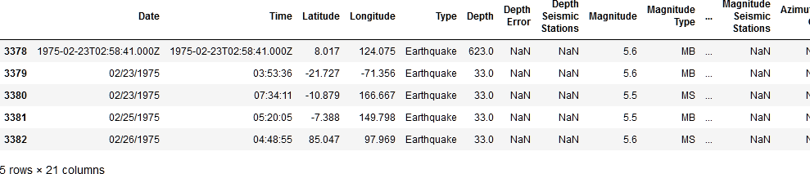

date_lengths = earthquakes.Date.str.len() date_lengths.value_counts()

10 23409

24 3

Name: Date, dtype: int64

indices = np.where([date_lengths == 24])[1] print('Indices with corrupted data:', indices) earthquakes.loc[indices]

Indices with corrupted data: [ 3378 7512 20650]

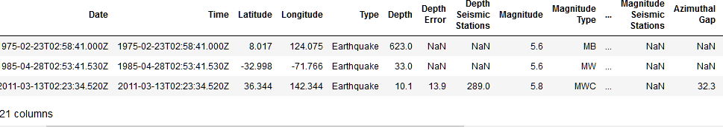

date_format = '%m/**%d**/%Y'

earthquakes.loc[indices,'Date'] = pd.to_datetime(earthquakes.loc[indices,'Date']) \

.dt.strftime(date_format)

earthquakes['date_parsed'] = pd.to_datetime(earthquakes['Date'])

day_of_month_earthquakes = earthquakes['date_parsed'].dt.day

sns.displot(day_of_month_earthquakes, kde=False, bins=31);

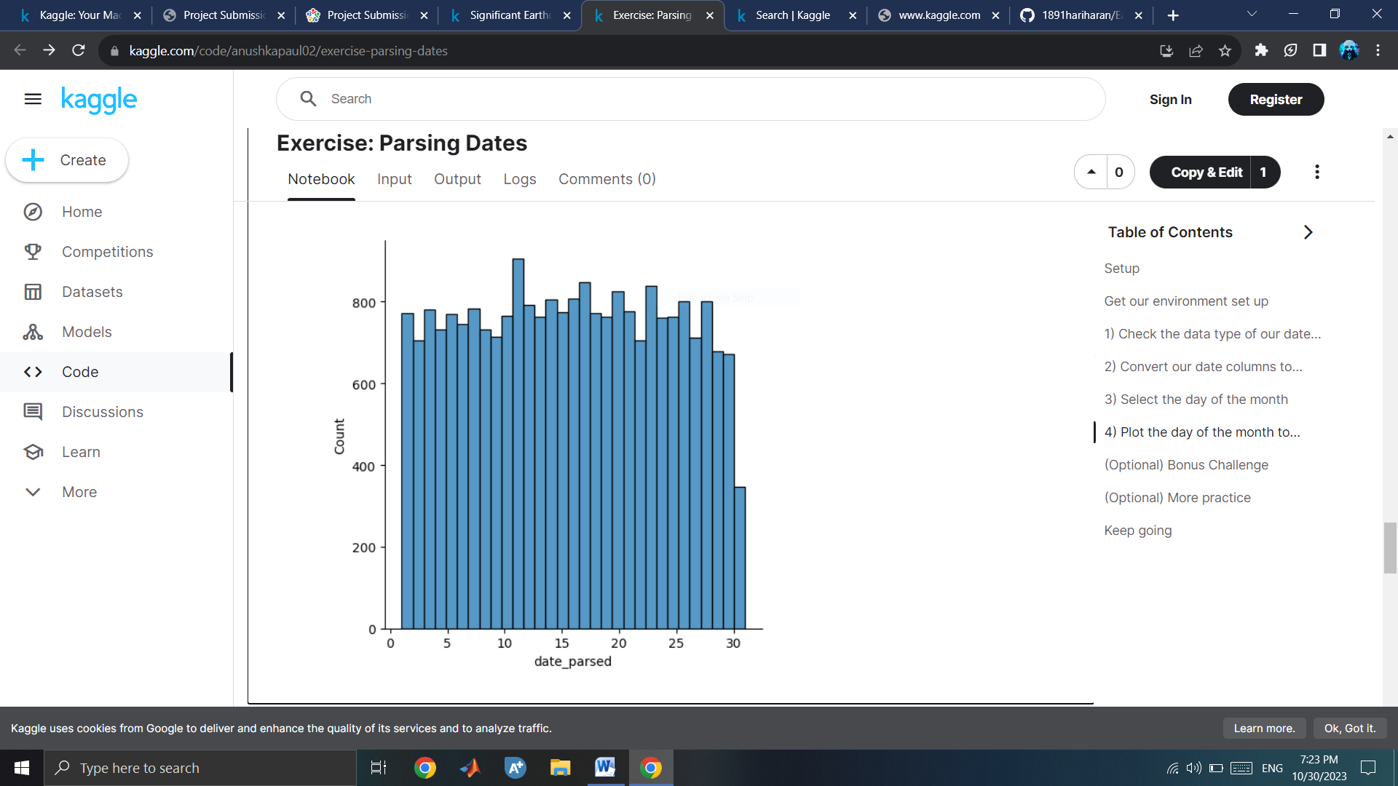

q4.check()

volcanos = pd.read_csv("../input/volcanic-eruptions/database.csv")

volcanos['Last Known Eruption'].sample(5)

764 Unknown

1069 1996 CE

34 1855 CE

489 2016 CE

9 1302 CE

Name: Last Known Eruption, dtype: object

**Conclusion;**

In conclusion, earthquake prediction remains an intricate and challenging field of study, with far-reaching implications for the safety and resilience of communities around the world. While substantial progress has been made in recent years, we must acknowledge that complete, precise, and long-term earthquake prediction continues to elude the scientific community.

The multifaceted nature of earthquakes, driven by complex geological processes, presents a formidable obstacle. Nevertheless, advancements in seismology, geodesy, and artificial intelligence offer promising avenues for improving our understanding of seismic activity.

These approaches have shown the potential for short-term forecasting, affording valuable seconds or minutes of warning, which can be crucial for disaster preparedness and response.

Moreover, the pursuit of earthquake prediction has not been in vain. Research in this field has led to a deeper comprehension of fault systems, stress accumulation, and regional seismic behavior. These insights contribute to the development of robust building codes, emergency plans, and early warning systems, all of which serve to reduce the devastation caused by earthquakes.

The future of earthquake prediction hinges on interdisciplinary collaboration, access to real-time data, and a continued commitment to research and innovation. While we may never achieve perfect predictability, we can make great strides in mitigating the impacts of earthquakes by investing in both scientific research and disaster preparedness. By combining our growing knowledge with advanced technologies, we can work toward a safer and more resilient future for earthquake-prone regions worldwide.